ØØ Explanation :
- We are given two numbers at memory locations D000 H and D001 H. Let these numbers be
20 H and 50 H.
- We have to add the byte at memory location D000 H ( 20 H ) with the byte at memory location D001 H ( 50 H).
- Initially we will store the first number in the accumulator.
- Using ADD instruction add the two contents. Result of addition will be stored in the A register.
- Store the result at memory location D002 H.
For example : | D000 H = 20 H |  | 20 H
 | D001 H = 50 H | + | 50 H
 |  |  | 70 H
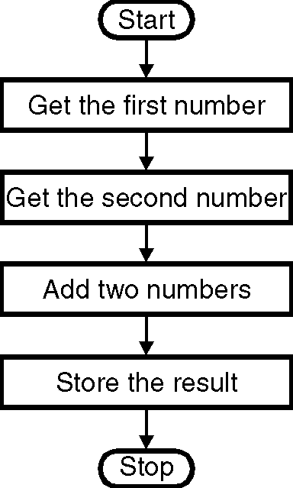
➢➢ Algorithm :
Step I : Start
Step II : Get the first number in A register.
Step III : Get the second number in memory.
Step IV : Add the two numbers.
Step V : Store the result at memory location D002 H.
Step VI : Stop
➢➢ Flowchart : Refer flowchart 4.
➢➢ Program :
Instruction Comment
LXI H, D000 H ; HL points to the memory location D000 H
MOV A, M ; Get the contents of location Flowchart 4
; D000 H into the accumulator.
INX H ; Increment HL to point to next memory location i.e. D001H
ADD M ; A = A +M i.e. compute the addition
INX H ; Increment HL to point to next memory location i.e. D002H
MOV M, A ; Store the result at memory location i.e. D002H
HLT

